**Security Pass System Ver-2.1**

**User Manual**

|  |  |
| --- | --- |
| **Software Application** | **Security Pass System (Eazy Pass)** |
| **Version** | **2.1** |
| **Licensed** | **Indian Oil Corporation** |
| **Developed by** | **COMSYS IT, New Delhi** |

**Technical Configuration**

|  |  |
| --- | --- |
| Software | Hardware |
| O/S:- Windows 7/8/10/SERVER  **With AAdhar Scanner or web Camera** | i3 Processor or higher |
| Front End: - PHP | 500 GB HDD or higher |
| Back End: - My SQL | 2 GB RAM |
| Reports: - PDF | Intranet / Internet |

**Overview**

Security Pass System was developed to automate the Detail of TT Driver / Helper. It is very easy to operate. This Software was successfully Developed and implemented by our Software Development Team. We also provide our services to IOCL time to time in several IT activity, and every time we satisfied with our dedicated services. The following lines highlight the features of the existing software.

Primarily The Software divided into four Parts:

1. **Master**
2. **Transactions**
3. **Reports**
4. **Utilities**

**Entering to the System**

To enter into the System, click on **IOCL** in the Desktop.

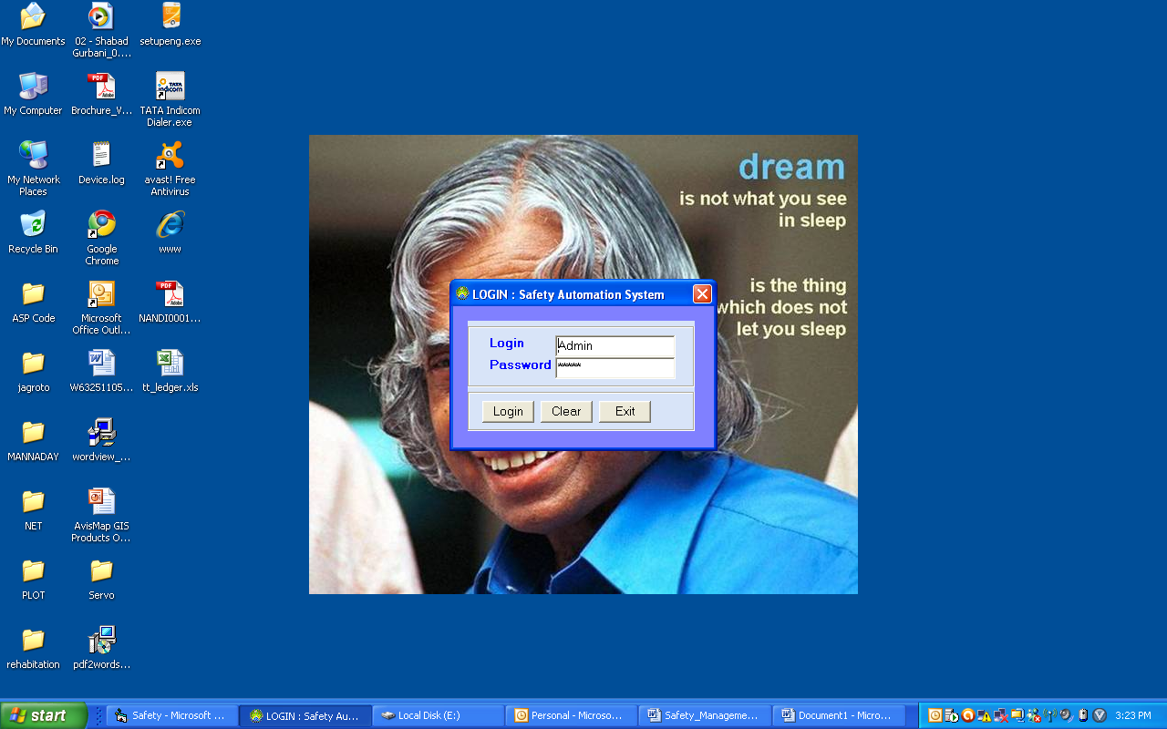

After that Enter user name and password to the login Screen and press **Login** button or press enter key in password text box.

**Table Name – company_master**

|  |  |  |  |
| --- | --- | --- | --- |
| **Field Name** | **Data Type** | **Length** | **Remarks** |
| **Location_Code** | **Text** | **20** | **IOCL Location Code** |
| **Location_name** | **Text** | **100** | **(Jamshedpur BP/ Paradeep Installation)** |
| **Location_Address** | **Text** | **240** |  |
| **Location_email** | **Text** | **100** |  |
| **Location_pnone** | **Text** | **50** |  |

**Table Name – User_master**

|  |  |  |  |
| --- | --- | --- | --- |
| **Field Name** | **Data Type** | **Length** | **Remarks** |
| **user_Type** | **Text** | **10** | **(Admin / User)** |
| **user_code** | **Text** | **25** |  |
| **user_name** | **Text** | **100** |  |
| **Cname** | **Text** | **240** |  |
| **phone** | **Text** | **30** |  |
| **Emai** | **Text** | **70** |  |
| **Location_Code** | **Text** | **20** | **IOCL Location Code** |

**Table Name – profile_master**

|  |  |  |  |
| --- | --- | --- | --- |
| **Field Name** | **Data Type** | **Length** | **Remarks** |
| **profile_code** | **Text** | **10** |  |
| **profile_name** | **Text** | **100** | **(Guard/ Plumber/ Haulage** |

**Masters**

|  |  |
| --- | --- |
| **Party** | The Party master stores the details of the Party.  The Red Marks Fields are mandatory  **Party** **Code** – It’s the SAP Code Assign to the Parties. This is Unique Code  **Name** – Name of the Party |

**Table Name – Party_Master**

|  |  |  |  |
| --- | --- | --- | --- |
| **Field Name** | **Data Type** | **Length** | **Remarks** |
| **Party_Type** | **Text** | **10** | **(Transporter / Contractor)** |
| **SAP Code** | **Text** | **20** | **10114590** |
| **party_name** | **Text** | **100** | **ABC Transporter** |
| **party_address** | **Text** | **240** |  |
| **phone** | **Text** | **30** |  |
| **Emai** | **Text** | **70** |  |
| **Location_Code** | **Text** | **20** | **IOCL Location Code** |

|  |  |
| --- | --- |
| **Party wise TT** | Here we stores the Party Code and his TT No.  The Red Marks Fields are mandatory  **Party** **Name** – Dropdown List Available here which stored in the Party Master  **TT** – Enter the TT Nos of the selected Parties one by one.  Green Card Detail / Calibration Date |

**Table Name – Party_Wise_TT**

|  |  |  |  |
| --- | --- | --- | --- |
| **Field Name** | **Data Type** | **Length** | **Remarks** |
| **SAP Code** | **Text** | **20** | **10114590** |
| **Truck_No** | **Text** | **50** | **HR-01-T-4569** |
| **calibration_date** | **Date** |  |  |
| **green_Card** | **Text** | **5** | **Yes/No** |
| **gcValid_from** | **Date** |  |  |
| **gcvalid_to** | **Date** |  |  |
| **Location_Code** | **Text** | **20** | **IOCL Location Code** |

**Transactions**

|  |  |
| --- | --- |
| **Driver /Helper** |  |

**Table Name – Truck_Data**

|  |  |  |  |
| --- | --- | --- | --- |
| **Field Name** | **Data Type** | **Length** | **Remarks** |
| **Card_Type** | **Text** | **10** | **Temporary / Permanent** |
| **PID** | **Text** | **20** | **Aadhar/ PAN No** |
| **TDate** | **Date** |  | **By default current date** |
| **Data_Type** | **Text** | **10** | **Driver/ Helper/ Munim** |
| **Pass_No** | **Text1** | **10** | **Alpha Numeric Auto generated Pass no** |
| **SAP Code** | **Text** | **20** | **Transporter Code** |
| **Truck_No** | **Text** | **50** | **HR-01-T-4569** |
| **PName** | **Text** | **50** | **Driver / helper Name** |
| **father_name** | **Text** | **50** | **Fathers name** |
| **DOB** | **Date** |  | **Date picker** |
| **Address** | **Text** | **240** | **Address** |
| **Phone** | **Text** | **50** | **Mobile No** |
| **License No** | **Text** | **100** | **Driver License no** |
| **LValid_Through** | **Date** |  | **Driver License Validity** |
| **Place_issue** | **Text** | **50** | **License Place of Issue** |
| **Police verification** | **Text** | **5** | **Yes/ NO** |
| **Police Station** | **Text** | **50** | **Polic Station Name** |
| **Ref_No** | **Text** | **100** | **Verification Document No** |
| **Eye_Sight** | **Text** | **10** | **OK/Poor** |
| **Form_J** | **Text** | **5** | **Yes/ NO** |
| **Form_H** | **Text** | **5** | **Yes/ NO** |
| **HG_Training** | **Text** | **5** | **Yes/ NO** |
| **HGValid_from** | **Date** |  | **Hazardous Training valid from** |
| **HGValid_from** | **Date** |  | **Hazardous Training valid to** |
| **cValid_from** | **Date** |  | **Card valid from** |
| **cvalid_to** | **Date** |  | **Card valid to** |
| **Block** | **Text** | **5** | **Yes/ NO** |
| **Block Date** | **Date** |  |  |
| **Block_Reaseon** | **Text** | **240** |  |
| **Block_by** | **Text** | **25** | **User id** |
| **Black_listed** | **Text** | **5** | **Yes/ NO** |
| **Blacklis Date** | **Date** |  |  |
| **Blacklist _Reaseon** | **Text** | **240** |  |
| **Blacklist _by** | **Text** | **25** | **User id** |
| **No_Renew** | **Number** |  | **No of Card Renew** |
| **Crated_Date** | **Date** |  | **Card create Date** |
| **Create_usesr** | **Text** |  | **User id** |
| **Attch_Doument** | **Text** | **240** | **Document attachment link** |
| **Location_Code** | **Text** | **20** | **IOCL Location Code** |

|  |  |
| --- | --- |
| **Labour/ Guard** |  |

**Table Name – Labour_Data**

|  |  |  |  |
| --- | --- | --- | --- |
| **Field Name** | **Data Type** | **Length** | **Remarks** |
| **Card_Type** | **Text** | **10** | **Temporary / Permanent** |
| **LID** | **Text** | **20** | **Aadhar/ PAN No** |
| **TDate** | **Date** |  | **By default current date** |
| **Data_Profile** | **Text** | **10** | **List from Profile master** |
| **Pass_No** | **Text1** | **10** | **Alpha Numeric Auto generated Pass no** |
| **SAP Code** | **Text** | **20** | **Contractor Code** |
| **PName** | **Text** | **50** | **Driver / helper Name** |
| **father_name** | **Text** | **50** | **Fathers name** |
| **DOB** | **Date** |  | **Date picker** |
| **Address** | **Text** | **240** | **Address** |
| **Phone** | **Text** | **50** | **Mobile No** |
| **Police verification** | **Text** | **5** | **Yes/ NO** |
| **Police Station** | **Text** | **50** | **Polic Station Name** |
| **Ref_No** | **Text** | **100** | **Verification Document No** |
| **Form_J** | **Text** | **5** | **Yes/ NO** |
| **Form_H** | **Text** | **5** | **Yes/ NO** |
| **cValid_from** | **Date** |  | **Card valid from** |
| **cvalid_to** | **Date** |  | **Card valid to** |
| **Block** | **Text** | **5** | **Yes/ NO** |
| **Block Date** | **Date** |  |  |
| **Block_Reaseon** | **Text** | **240** |  |
| **Block_by** | **Text** | **25** | **User id** |
| **Black_listed** | **Text** | **5** | **Yes/ NO** |
| **Blacklis Date** | **Date** |  |  |
| **Blacklist _Reaseon** | **Text** | **240** |  |
| **Blacklist _by** | **Text** | **25** | **User id** |
| **No_Renew** | **Number** |  | **No of Card Renew** |
| **Crated_Date** | **Date** |  | **Card create Date** |
| **Create_usesr** | **Text** |  | **User id** |
| **Location_Code** | **Text** | **20** | **IOCL Location Code** |

**Table Name – Log_Driver**

|  |  |  |  |
| --- | --- | --- | --- |
| **Field Name** | **Data Type** | **Length** | **Remarks** |
| **Log_Type** | **Text** | **5** | **BK / BL/TR** |
| **TID** | **Text** | **20** | **Aadhar/ PAN No** |
| **BKDate** | **Date** |  | **By default current date** |
| **Pass_No** | **Text1** | **10** | **Alpha Numeric Auto generated Pass no** |
| **Action** | **Text** | **10** | **Block/ UBlock Black/UBlack**  **Temp/Per** |
| **Reaseon** | **Text** | **240** |  |
| **Block_by** | **Text** | **25** | **User id** |
| **Location_Code** | **Text** | **20** | **IOCL Location Code** |

**Table Name – Log_Labour**

|  |  |  |  |
| --- | --- | --- | --- |
| **Field Name** | **Data Type** | **Length** | **Remarks** |
| **Log_Type** | **Text** | **5** | **BK / BL/TR** |
| **LID** | **Text** | **20** | **Aadhar/ PAN No** |
| **BKDate** | **Date** |  | **By default current date** |
| **Pass_No** | **Text1** | **10** | **Alpha Numeric Auto generated Pass no** |
| **Action** | **Text** | **10** | **Block/ UBlock Black/UBlack**  **Temp/Per** |
| **Block_Reaseon** | **Text** | **240** |  |
| **Block_by** | **Text** | **25** | **User id** |
| **Location_Code** | **Text** | **20** | **IOCL Location Code** |

|  |  |
| --- | --- |
| **Black Listed** | This is to facilitate the user to mark as Black listed to any individual Driver/Helper of Labour /Guard for any malicious activity.    For Black Listed   * Type Card No its automatically show the detail of driver / Helper / Labour / Guard detail then click (YES) in Black list box |
| **Search Engine party wise tt Detail** | For Search   * Select party it’s automatically showing the no of TTs assign to the party. Can viwe the history of Driver / Helper. |

|  |  |
| --- | --- |
| **Block Card** | This Option is provided to block the particular Card of any Driver / Helper or Labour / Guard.    Operation Function   * Select the Parties form Drop down box. * The **Driver / Helper or Labour / Guard** of the parties reflect in the below left grid * Select the desire record in the Grid to block the Card * Click the Block button provided. * The successful transaction will reflect in the right grid * Click the **Un Block Card** button provided to Un Block anyCard |

**Reports**

|  |  |
| --- | --- |
| **Master Report** | The Party, Party wise TT master can be view here. |
| **Validation report** | This report give you the information before 30 days which driver / Helper card is expired. |
| **Ledger report** | Give complete information with TT Wise of driver / Helper detail |
| **Black Listed** | This Report give you the information about driver / Helper detail are black listed. |

**Utilities**

|  |  |
| --- | --- |
| **Data back up and Recovery** | Data Backup provided the back up of the current data to prevent the data lose through recover. |
| **Data Transfer** | Data will be transferred. |
| **Data Clear** | Database will be blank |

**Admin**

|  |  |
| --- | --- |
| **Account** | User account can be created. User ID should be unique. |
| **Show Account** | All User ID and Password show in grid. |

**Help Desk/ Assistance**

For further any Assistance Pls. Contact;

**Vinod Rai (Project In charge)**

Ph:-09350288707

E-mail:-comsys@mail.com, vinod74_rai@rediffmail.com